Week 1: Daily Journals

Monday:
Today marked the commencement of the 2026 Summer Research Program. My group began with a kickoff meeting to review the project overview and objectives for the six-week program. Following the meeting, I conducted an inventory check to identify the necessary components for fabricating four distinct cables required for our upcoming testing. Lastly, I reviewed our Python-based Mode Manager program to verify that it functions as predicted ahead of our Flatsat testing.

Tuesday:
On the second day, my group began fabricating the required cabling. We initiated the process by soldering six 22-gauge wires into a 9-pin D-sub male connector; this cable will handle power distribution between our three power supplies and the switchboard. Next, we began soldering 25 individual 24-gauge wires to a 25-pin D-sub male connector, which will interface the switchboard with the Raspberry Pi 4’s GPIO pins. To optimize efficiency, we established a two-person pipeline: one person handled the soldering while the other prepared the subsequent wires and applied labels. Our specific pinout configuration is documented in Figure 1.
Wednesday:
Today, we completed fabrication for the majority of the remaining cables. This included assembling a 9-pin D-sub male connector cable to interface the Switchboard with the Antenna Interface Board (AIB), as well as another 9-pin D-sub male connector cable intended for the Switchboard-to-camera interface. Once assembly was complete, I organized and laid out all available components and cabling for the Flatsat integration (displayed in Figure 2). We are currently awaiting the delivery of the switchboard, Pi Hat, X-Ray sensor, and the dedicated X-Ray sensor cable.
Thursday:
Today, we identified a design discrepancy: the cable interfacing the switchboard and the cameras required a 15-pin D-sub connector rather than the 9-pin connector we had assembled. To correct this, we desoldered the 9-pin connector and resoldered the wire harness to a 15-pin connector. Afterward, I began developing a Python-based diagnostic utility to verify that the Pi 4 software executes correctly within the Flatsat environment. This script is designed to run prior to testing cycles to ensure hardware health. The program executes the following sequential routine:
- Runs a basic hardware diagnostic test on the Pi 4.
- Monitors the ESim heartbeat signal.
- Verifies Ethernet-over-USB commanding functionality from the ESim to the Pi.
- Confirms successful data file retrieval from the ESim.
- Verifies commanded mode transitions and ensures a notification packet is transmitted back to the ESim upon every transition.

Friday:
Today was dedicated to refining and finalizing the Pi 4 software diagnostic program. I focused on optimizing the code structure to ensure all test cases execute reliably. I plan to run full integration testing with this script on Monday. With development wrapped up for the day, I concluded my tasks for the week.

Pictures
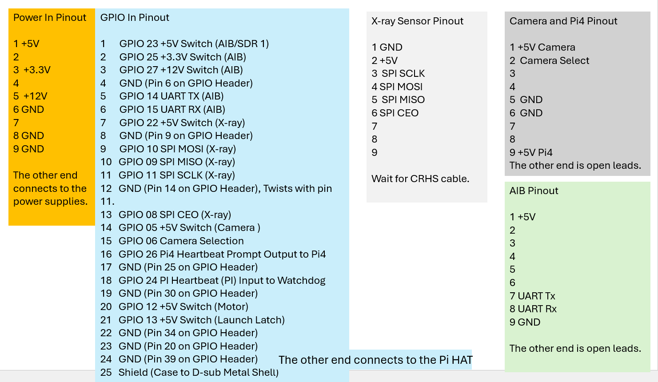
Figure 1: Pinout Diagram
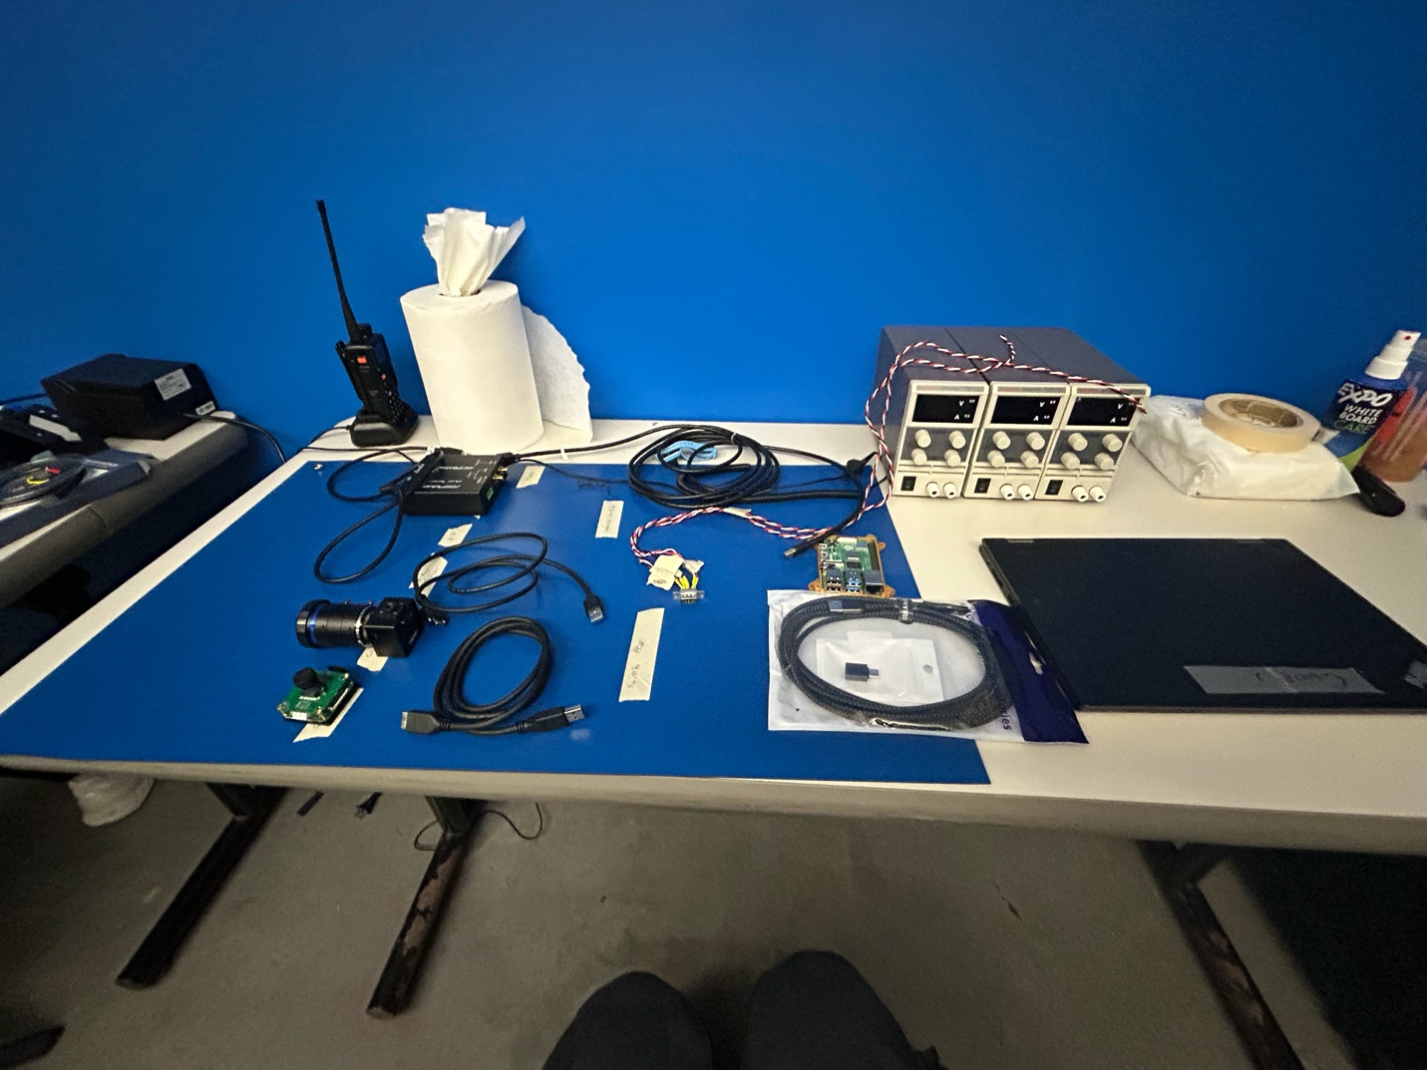
Figure 2: FlatSat Layout

